Analysis of the cnn model:
KerasModel = keras.models.Sequential([
keras.layers.Conv2D(200,kernel_size=(3,3),activation='relu',input_shape=(s,s,3)),
keras.layers.Conv2D(150,kernel_size=(3,3),activation='relu'),
keras.layers.MaxPool2D(4,4),
keras.layers.Conv2D(120,kernel_size=(3,3),activation='relu'),
keras.layers.Conv2D(80,kernel_size=(3,3),activation='relu'),
keras.layers.Conv2D(50,kernel_size=(3,3),activation='relu'),
keras.layers.MaxPool2D(4,4),
keras.layers.Flatten() ,
keras.layers.Dense(120,activation='relu') ,
keras.layers.Dense(100,activation='relu') ,
keras.layers.Dense(50,activation='relu') ,
keras.layers.Dropout(rate=0.5) ,
keras.layers.Dense(5,activation='softmax') ,
])

print('Model Details are : ')
print(KerasModel.summary())
output
Model Details are :
Model: "sequential"
_________________________________________________________________
Layer (type) Output Shape Param #
=================================================================
conv2d (Conv2D) (None, 254, 254, 200) 5600

conv2d_1 (Conv2D) (None, 252, 252, 150) 270150

max_pooling2d (MaxPooling2 (None, 63, 63, 150) 0
D)

conv2d_2 (Conv2D) (None, 61, 61, 120) 162120

conv2d_3 (Conv2D) (None, 59, 59, 80) 86480

conv2d_4 (Conv2D) (None, 57, 57, 50) 36050

max_pooling2d_1 (MaxPoolin (None, 14, 14, 50) 0
g2D)

flatten (Flatten) (None, 9800) 0

dense (Dense) (None, 120) 1176120

dense_1 (Dense) (None, 100) 12100

dense_2 (Dense) (None, 50) 5050

dropout (Dropout) (None, 50) 0

dense_3 (Dense) (None, 5) 255

=================================================================
Total params: 1753925 (6.69 MB)
Trainable params: 1753925 (6.69 MB)
Non-trainable params: 0 (0.00 Byte)
____________________________________

epochs = 50
# Define Early Stopping callback
early_stopping = EarlyStopping(monitor='val_loss', patience=5)

history = KerasModel.fit(X_train, y_train,
epochs=epochs,
batch_size=32,
validation_data=(X_test, y_test),
callbacks=[early_stopping])

changing the model layers as follows:
KerasModel = keras.models.Sequential([
keras.layers.Conv2D(200,kernel_size=(3,3),activation='relu',input_shape=(s,s,3)),
keras.layers.Conv2D(150,kernel_size=(3,3),activation='relu'),
keras.layers.MaxPool2D(4,4),
keras.layers.Conv2D(120,kernel_size=(3,3),activation='relu'),
keras.layers.MaxPool2D(4,4),
keras.layers.Flatten() ,
keras.layers.Dense(120,activation='relu') ,
keras.layers.Dense(100,activation='relu') ,
keras.layers.Dropout(rate=0.5) ,
keras.layers.Dense(5,activation='softmax') ,
])
The output will be as follows:
Epoch 1/50
126/126 [==============================] - 114s 891ms/step - loss: 4.5913 - accuracy: 0.4334 - val_loss: 1.0759 - val_accuracy: 0.6099
Epoch 2/50
126/126 [==============================] - 116s 918ms/step - loss: 0.9436 - accuracy: 0.6643 - val_loss: 0.7886 - val_accuracy: 0.7234
Epoch 3/50
126/126 [==============================] - 116s 918ms/step - loss: 0.7253 - accuracy: 0.7430 - val_loss: 0.7944 - val_accuracy: 0.7163
Epoch 4/50
126/126 [==============================] - 116s 918ms/step - loss: 0.5901 - accuracy: 0.7945 - val_loss: 0.7419 - val_accuracy: 0.7376
Epoch 5/50
126/126 [==============================] - 113s 899ms/step - loss: 0.4121 - accuracy: 0.8576 - val_loss: 0.7580 - val_accuracy: 0.7541
Epoch 6/50
126/126 [==============================] - 116s 921ms/step - loss: 0.3360 - accuracy: 0.8859 - val_loss: 0.8574 - val_accuracy: 0.7447
Epoch 7/50
126/126 [==============================] - 115s 915ms/step - loss: 0.3765 - accuracy: 0.8802 - val_loss: 0.9372 - val_accuracy: 0.7494
Epoch 8/50
126/126 [==============================] - 115s 916ms/step - loss: 0.2289 - accuracy: 0.9212 - val_loss: 0.9955 - val_accuracy: 0.7565
Epoch 9/50
126/126 [==============================] - 115s 915ms/step - loss: 0.2141 - accuracy: 0.9304 - val_loss: 1.0974 - val_accuracy: 0.7612
Clearly overfitting!
plt.plot(history.history['accuracy'], label='Training Accuracy')
plt.plot(history.history['val_accuracy'], label='Validation Accuracy')
plt.xlabel('Epoch')
plt.ylabel('Accuracy')
plt.legend()
plt.show()
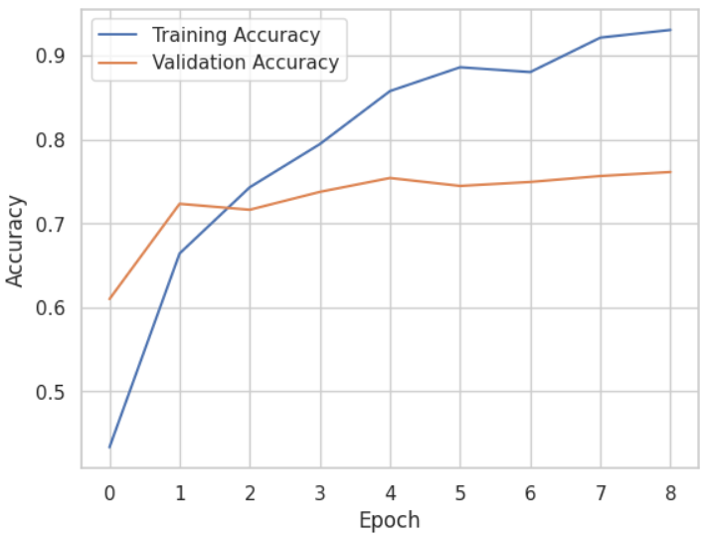

Epoch 1/35
126/126 [==============================] - 23s 151ms/step - loss: 9.3770 - accuracy: 0.4043 - val_loss: 1.2004 - val_accuracy: 0.5650
Epoch 2/35
126/126 [==============================] - 17s 134ms/step - loss: 1.2218 - accuracy: 0.5403 - val_loss: 1.2630 - val_accuracy: 0.5201
Epoch 3/35
126/126 [==============================] - 17s 134ms/step - loss: 1.1104 - accuracy: 0.5845 - val_loss: 1.0281 - val_accuracy: 0.6123
Epoch 4/35
126/126 [==============================] - 17s 133ms/step - loss: 0.9389 - accuracy: 0.6588 - val_loss: 0.9786 - val_accuracy: 0.6217
Epoch 5/35
126/126 [==============================] - 17s 132ms/step - loss: 0.8879 - accuracy: 0.6697 - val_loss: 1.2101 - val_accuracy: 0.5437
Epoch 6/35
126/126 [==============================] - 17s 134ms/step - loss: 0.7957 - accuracy: 0.7090 - val_loss: 0.9910 - val_accuracy: 0.6430
Epoch 7/35
126/126 [==============================] - 17s 133ms/step - loss: 0.7127 - accuracy: 0.7440 - val_loss: 1.0212 - val_accuracy: 0.6407
Epoch 8/35
126/126 [==============================] - 17s 132ms/step - loss: 0.6403 - accuracy: 0.7853 - val_loss: 0.9902 - val_accuracy: 0.6879
Epoch 9/35
126/126 [==============================] - 17s 134ms/step - loss: 0.5206 - accuracy: 0.8072 - val_loss: 0.8585 - val_accuracy: 0.7447
Epoch 10/35
126/126 [==============================] - 17s 133ms/step - loss: 0.4659 - accuracy: 0.8283 - val_loss: 0.8394 - val_accuracy: 0.7376
Epoch 11/35
126/126 [==============================] - 17s 132ms/step - loss: 0.4212 - accuracy: 0.8454 - val_loss: 0.9727 - val_accuracy: 0.7376
Epoch 12/35
126/126 [==============================] - 17s 132ms/step - loss: 0.3816 - accuracy: 0.8651 - val_loss: 0.9843 - val_accuracy: 0.7376
Epoch 13/35
126/126 [==============================] - 17s 133ms/step - loss: 0.3672 - accuracy: 0.8723 - val_loss: 0.9613 - val_accuracy: 0.7329
Epoch 14/35
126/126 [==============================] - 17s 132ms/step - loss: 0.3348 - accuracy: 0.8743 - val_loss: 0.9214 - val_accuracy: 0.6974
Epoch 15/35
126/126 [==============================] - 17s 132ms/step - loss: 0.3379 - accuracy: 0.8628 - val_loss: 1.3219 - val_accuracy: 0.7139
KerasModel = keras.models.Sequential([
keras.layers.Conv2D(200,kernel_size=(3,3),activation='relu',input_shape=(s,s,3)),
keras.layers.MaxPool2D(4,4),
keras.layers.Conv2D(150,kernel_size=(3,3),activation='relu'),
keras.layers.MaxPool2D(4,4),
keras.layers.Flatten() ,
keras.layers.Dense(120,activation='relu') ,
keras.layers.Dropout(rate=0.6) ,
keras.layers.Dense(5,activation='softmax') ,
])
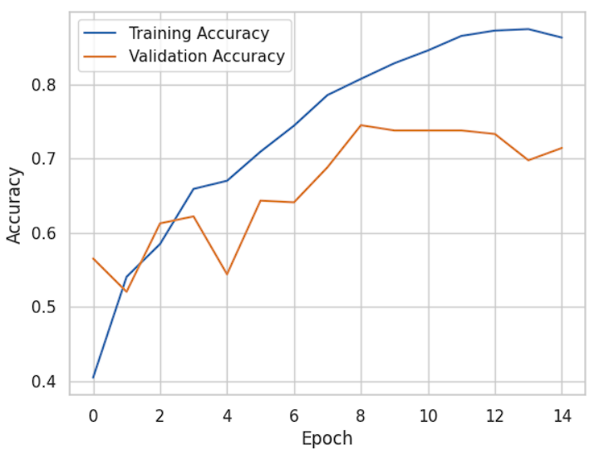
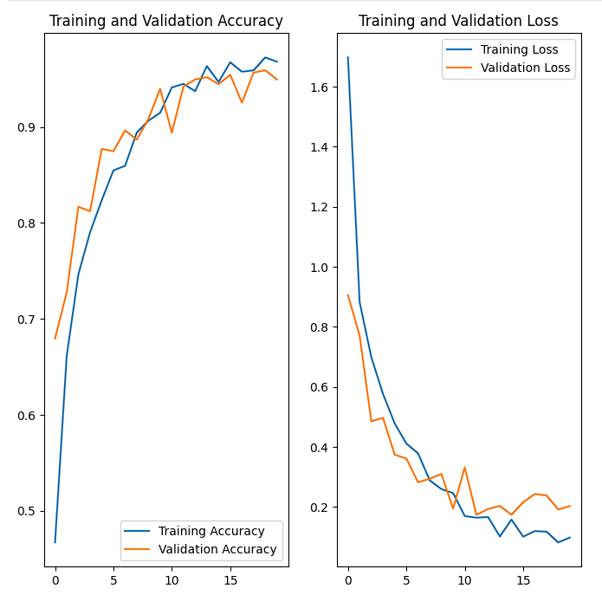
Epoch 1/20
111/111 ━━━━━━━━━━━━━━━━━━━━ 57s 502ms/step - accuracy: 0.3448 - loss: 3.2059 - val_accuracy: 0.6795 - val_loss: 0.9057
Epoch 2/20
111/111 ━━━━━━━━━━━━━━━━━━━━ 55s 496ms/step - accuracy: 0.6621 - loss: 0.8947 - val_accuracy: 0.7277 - val_loss: 0.7708
Epoch 3/20
111/111 ━━━━━━━━━━━━━━━━━━━━ 55s 493ms/step - accuracy: 0.7351 - loss: 0.7130 - val_accuracy: 0.8169 - val_loss: 0.4853
Epoch 4/20
111/111 ━━━━━━━━━━━━━━━━━━━━ 55s 493ms/step - accuracy: 0.7939 - loss: 0.5602 - val_accuracy: 0.8120 - val_loss: 0.4970
Epoch 5/20
111/111 ━━━━━━━━━━━━━━━━━━━━ 57s 513ms/step - accuracy: 0.8161 - loss: 0.4804 - val_accuracy: 0.8771 - val_loss: 0.3745
Epoch 6/20
111/111 ━━━━━━━━━━━━━━━━━━━━ 55s 493ms/step - accuracy: 0.8529 - loss: 0.4155 - val_accuracy: 0.8747 - val_loss: 0.3614
Epoch 7/20
111/111 ━━━━━━━━━━━━━━━━━━━━ 55s 497ms/step - accuracy: 0.8703 - loss: 0.3622 - val_accuracy: 0.8964 - val_loss: 0.2827
Epoch 8/20
111/111 ━━━━━━━━━━━━━━━━━━━━ 55s 498ms/step - accuracy: 0.8912 - loss: 0.3066 - val_accuracy: 0.8867 - val_loss: 0.2940
Epoch 9/20
111/111 ━━━━━━━━━━━━━━━━━━━━ 55s 498ms/step - accuracy: 0.9171 - loss: 0.2375 - val_accuracy: 0.9084 - val_loss: 0.3103
Epoch 10/20
111/111 ━━━━━━━━━━━━━━━━━━━━ 55s 495ms/step - accuracy: 0.9216 - loss: 0.2276 - val_accuracy: 0.9398 - val_loss: 0.1948
Epoch 11/20
111/111 ━━━━━━━━━━━━━━━━━━━━ 55s 494ms/step - accuracy: 0.9437 - loss: 0.1676 - val_accuracy: 0.8940 - val_loss: 0.3321
Epoch 12/20
111/111 ━━━━━━━━━━━━━━━━━━━━ 55s 496ms/step - accuracy: 0.9427 - loss: 0.1612 - val_accuracy: 0.9422 - val_loss: 0.1742
Epoch 13/20
111/111 ━━━━━━━━━━━━━━━━━━━━ 55s 495ms/step - accuracy: 0.9416 - loss: 0.1524 - val_accuracy: 0.9494 - val_loss: 0.1937
Epoch 14/20
111/111 ━━━━━━━━━━━━━━━━━━━━ 55s 500ms/step - accuracy: 0.9682 - loss: 0.0915 - val_accuracy: 0.9518 - val_loss: 0.2038
Epoch 15/20
111/111 ━━━━━━━━━━━━━━━━━━━━ 55s 493ms/step - accuracy: 0.9637 - loss: 0.1169 - val_accuracy: 0.9446 - val_loss: 0.1745
Epoch 16/20
111/111 ━━━━━━━━━━━━━━━━━━━━ 57s 510ms/step - accuracy: 0.9690 - loss: 0.1007 - val_accuracy: 0.9542 - val_loss: 0.2162
Epoch 17/20
111/111 ━━━━━━━━━━━━━━━━━━━━ 59s 529ms/step - accuracy: 0.9583 - loss: 0.1163 - val_accuracy: 0.9253 - val_loss: 0.2436
Epoch 18/20
111/111 ━━━━━━━━━━━━━━━━━━━━ 62s 554ms/step - accuracy: 0.9592 - loss: 0.1125 - val_accuracy: 0.9566 - val_loss: 0.2387
Epoch 19/20
111/111 ━━━━━━━━━━━━━━━━━━━━ 55s 500ms/step - accuracy: 0.9739 - loss: 0.0893 - val_accuracy: 0.9590 - val_loss: 0.1919
Epoch 20/20
111/111 ━━━━━━━━━━━━━━━━━━━━ 55s 496ms/step - accuracy: 0.9705 - loss: 0.0981 - val_accuracy: 0.9494 - val_loss: 0.2032

odel: "sequential_56"
┏━━━━━━━━━━━━━━━━━━━━━━━━━━━━━━━━━━━━━━┳━━━━━━━━━━━━━━━━━━━━━━━━━━━━━┳━━━━━━━━━━━━━━━━━┓
┃ Layer (type) ┃ Output Shape ┃ Param # ┃
┡━━━━━━━━━━━━━━━━━━━━━━━━━━━━━━━━━━━━━━╇━━━━━━━━━━━━━━━━━━━━━━━━━━━━━╇━━━━━━━━━━━━━━━━━┩
│ conv2d_237 (Conv2D) │ (None, 254, 254, 32) │ 896 │
├──────────────────────────────────────┼─────────────────────────────┼─────────────────┤
│ max_pooling2d_230 (MaxPooling2D) │ (None, 127, 127, 32) │ 0 │
├──────────────────────────────────────┼─────────────────────────────┼─────────────────┤
│ conv2d_238 (Conv2D) │ (None, 125, 125, 64) │ 18,496 │
├──────────────────────────────────────┼─────────────────────────────┼─────────────────┤
│ max_pooling2d_231 (MaxPooling2D) │ (None, 62, 62, 64) │ 0 │
├──────────────────────────────────────┼─────────────────────────────┼─────────────────┤
│ conv2d_239 (Conv2D) │ (None, 60, 60, 64) │ 36,928 │
├──────────────────────────────────────┼─────────────────────────────┼─────────────────┤
│ max_pooling2d_232 (MaxPooling2D) │ (None, 30, 30, 64) │ 0 │
├──────────────────────────────────────┼─────────────────────────────┼─────────────────┤
│ conv2d_240 (Conv2D) │ (None, 28, 28, 64) │ 36,928 │
├──────────────────────────────────────┼─────────────────────────────┼─────────────────┤
│ max_pooling2d_233 (MaxPooling2D) │ (None, 14, 14, 64) │ 0 │
├──────────────────────────────────────┼─────────────────────────────┼─────────────────┤
│ conv2d_241 (Conv2D) │ (None, 12, 12, 64) │ 36,928 │
├──────────────────────────────────────┼─────────────────────────────┼─────────────────┤
│ max_pooling2d_234 (MaxPooling2D) │ (None, 6, 6, 64) │ 0 │
├──────────────────────────────────────┼─────────────────────────────┼─────────────────┤
│ conv2d_242 (Conv2D) │ (None, 4, 4, 64) │ 36,928 │
├──────────────────────────────────────┼─────────────────────────────┼─────────────────┤
│ max_pooling2d_235 (MaxPooling2D) │ (None, 2, 2, 64) │ 0 │
├──────────────────────────────────────┼─────────────────────────────┼─────────────────┤
│ flatten_57 (Flatten) │ (None, 256) │ 0 │
├──────────────────────────────────────┼─────────────────────────────┼─────────────────┤
│ dense_114 (Dense) │ (None, 64) │ 16,448 │
├──────────────────────────────────────┼─────────────────────────────┼─────────────────┤
│ dense_115 (Dense) │ (None, 5) │ 325 │
└──────────────────────────────────────┴─────────────────────────────┴─────────────────┘
Total params: 183,877 (718.27 KB)
Trainable params: 183,877 (718.27 KB)
Non-trainable params: 0 (0.00 B)
Training with training set only without data augmentation or normalization
history = KerasModel.fit(
train_ds,
batch_size=BATCH_SIZE,
validation_data=val_ds,
verbose=1,
epochs=EPOCHS,
)

